The Project Gutenberg eBook, Bluff Crag, by Mrs. George Cupples
This eBook is for the use of anyone anywhere at no cost and with almost no restrictions whatsoever. You may copy it, give it away or re-use it under the terms of the Project Gutenberg License included with this eBook or online at www.gutenberg.org
Title: Bluff Crag
or, A Good Word Costs Nothing
Author: Mrs. George Cupples
Release Date: May 28, 2007 [eBook #21636]
Language: English
Character set encoding: UTF-8
***START OF THE PROJECT GUTENBERG EBOOK BLUFF CRAG***
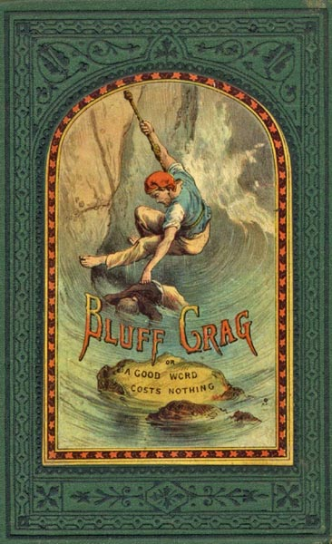
E-text prepared by Marilynda Fraser-Cunliffe, Janet Blenkinship, and the Project Gutenberg Online Distributed Proofreading Team (http://www.pgdp.net) from page images generously made available by the International Children's Digital Library (http://www.icdlbooks.org/)

Note: | Images of the original pages are available through the International Children's Digital Library. See http://www.childrenslibrary.org/icdl/BookPreview?bookid=cupbluf_00360203&summary=true&categories=false&route=advanced_0_0_cupples_English_0_all&lang=English&msg=

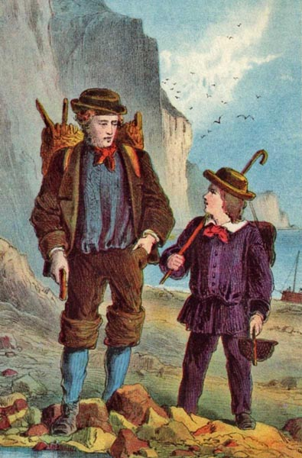A SCENE AT BLUFF CRAG.
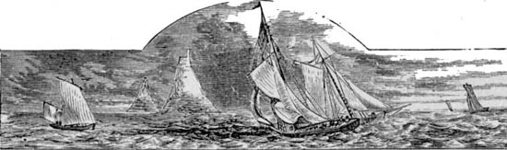

BLUFF CRAG;
OR,
A GOOD WORD COSTS NOTHING.

A Tale for the Young.
By
Mrs. GEORGE CUPPLES,
AUTHOR OF "THE STORY OF OUR DOLL," "THE LITTLE CAPTAIN,"
ETC., ETC.
LONDON:
T. NELSON AND SONS, PATERNOSTER ROW;
EDINBURGH; AND NEW YORK.
1872.

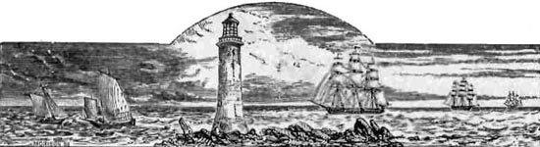
BLUFF CRAG.

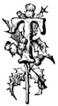
HIS is such a capital night for a story, papa," said Robert Lincoln to his father, who had laid away his newspaper and seemed inclined to take an extra forty winks.
"Indeed, Robert," said Mr. Lincoln, smiling, "I wonder if you would ever tire of hearing stories. I don't think I have one left; you and Lily have managed to exhaust my store."
"O papa, please don't say that," cried Lily, who was putting away her school-books on their proper shelf at the end of the room. "I am sure, if you shut your eyes and think very hard for a few minutes, you will be sure to find one."
"Very well, then, I shall try," said Mr. Lincoln; "perhaps there may be one among the cobwebs in my brain." Covering his face over with his newspaper, Mr. Lincoln lay back in his chair, and the children, drawing their stools closer to the fire, waited in patience to see the result of his meditation. It soon became evident, however, by his breathing, which became louder and longer, that Mr. Lincoln was falling asleep, and when at last he gave a loud snore, Robert could stand it no longer, and springing up, pulled the newspaper away, exclaiming,—
"O papa, you were actually going to sleep! You'll never find the story if you do!"
"I think, after all, I must have dropped over," said Mr. Lincoln, rubbing his eyes; "but you are wrong in thinking I couldn't find a story in my sleep, for I was just in the middle of such a nice one, when you wakened me, and, lo and behold, I found it was a dream."
"Oh, do tell us what you dreamed, papa," said Lily. "Your dreams are so funny sometimes. I think I like them better than the real stories."
"But it was only a bit of a dream. Bob there in his impatience knocked off the end, and I think it was going to be a very entertaining one."
"I'll tell you how you can manage, papa," said Lily earnestly, "you can make an end to it as you go along: you do tell us such nice stories out of your head."
Mrs. Lincoln having come into the room with the two younger children, a chair was placed for her and baby beside Mr. Lincoln. Little Dick trotted off to Robert's knee, and the dog, Charley, hearing that a story was going to be told, laid himself down on the rug before the fire, at Lily's feet.
"It's a very strange story, mamma," said Robert. "Papa fell asleep for two or three minutes, and dreamed the beginning of it. I am so sorry I wakened him; but he gave such a loud snore, I never thought he could be dreaming when he did that."
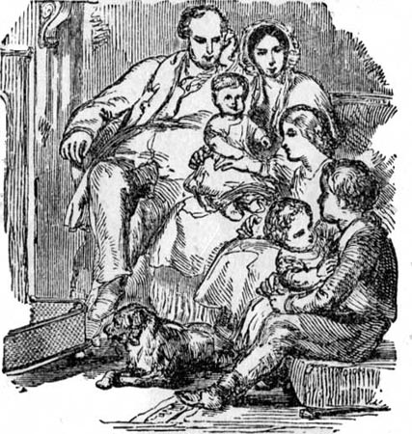WAITING FOR PAPA'S STORY.
"Ah, but you are wrong there," said Mr. Lincoln, laughing; "you will hear the reason of the snore very soon. Well, then, to begin—but how can I begin? Lily likes stories to set out with 'Once upon a time;' and you, Master Bob, like me to mention the hero's name, and tell you how old he is, and describe him particularly. Now, in this case, I can do neither."
"You will require to say, Once upon a time, when I was taking 'forty winks,'" said Mrs. Lincoln, laughing. "I cannot see how you are to relate this strange story without a beginning."
"Neither can I," said Mr. Lincoln. "You know everything depends upon a good beginning. Therefore I think I had better go to sleep again, and perhaps I shall dream one."
"Oh, please, papa, don't; I am sure the one mamma suggested is first-rate," said Robert impatiently.
"Very well, then, once upon a time I dreamed a dream—"
"It's Joseph and his broders papa is going to tell us about," cried little Dick. "Oh, I like that."
Every one laughed, while Robert explained that this was papa's dream, not Joseph's; which set the little fellow's mind wandering away still more into the favourite narrative, and it was only after a whispered threat from Robert that he would be taken up to the nursery if he did not sit quiet and listen, that he consented to leave Joseph and his brethren alone for the present.
"It's no use," said Mr. Lincoln, laughing, "somehow the dream has fled. I'll tell you what we shall do,—we shall ask mamma to tell one of her stories about when she was a little girl."
"I should like to have heard the dream, papa," said Lily, "but if it has fled away it won't be brought back. I know I never can get mine to do it till perhaps just when I am not thinking about it, then there, it is quite distinctly."
"Well, that will be the way mine may do," said Mr. Lincoln. "Come, mamma, we are waiting for yours. A good story-teller should begin without delay, and we all know what a capital one you are."
"Very well, then," said Mrs. Lincoln. "You must know that when I was a little girl I had been ill, and your grandmamma sent me to live with her brother, my Uncle John, who was the rector of the neighbouring parish. Uncle John had no children, and his wife had died just a few weeks before I went to pay him this visit. He had been very fond of my aunt, and he was still very sad about her death; so that it would have been rather a dull life but for Dolly, the housekeeper. Every morning after breakfast Dolly had to go for potatoes to a small field at a little distance from the rectory, and she usually took me with her if the day was fine. I ran about so much chasing butterflies and birds, that when the basket was filled I was quite tired out, and very glad to be placed upon the wheel-barrow and be taken home in this manner by the good-natured Dolly.
"And had you no little girl to play with, mamma?" asked Robert.
"Not for some time," replied Mrs. Lincoln. "Every one knew how sad my uncle was, and did not intrude upon him; but I never wearied so long as I had Dolly beside me. She could not read herself, but she was very fond of hearing me read to her, and though I could not do it very well then, I managed to make out the stories. Then your grandmamma had taught me a number of hymns, and I used to repeat them, and sometimes to sing them, which pleased Dolly very much. I think it was overhearing me singing one of the hymns that made Uncle John take notice of me at last. He used to shut himself in his study, and I scarcely ever saw him from one week's end to the other; but one day as he was going up-stairs I had been singing, and he came into the parlour, and, taking me on his knee, asked me to sing the hymn over again. I was a little nervous at first, but grandmamma had always told me to do the best I could when asked to repeat or sing a hymn, and I did so now. I suppose the words of the hymn pleased him, for from that time he always had me to dine with him; and he had such a kind manner, that I soon recovered from my shyness, and used to sit on his knee and prattle away to him as if he had been your grandpapa, and I had known him all my life. It made Dolly so pleased, too, for she said her master was beginning to look quite like his old self; and she only hoped your grandmamma would allow me to stay ever so long with him.
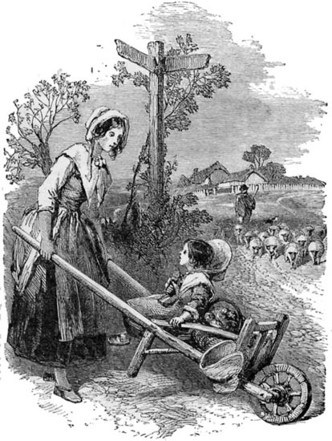COMING FROM THE POTATO-FIELD.
"One day Uncle John returned earlier than usual, and calling Dolly, said, 'Get Miss Lilian ready to go out. Mrs. Berkley wishes me to spend the afternoon there, and I think it will do the child good. I fear she has had but a dull time of it lately.'
"'Oh, please don't say that, uncle!' I exclaimed. 'I would rather stay at home with Dolly;' for the thought of the grand Mrs. Berkley, who came into church with her powdered footman carrying her Bible behind her, frightened me.
"'No, no, my child; you must go with me,' said Uncle John quietly. 'It isn't good for you to be so much alone. You will have a good romp with some young people who are staying with Mrs. Berkley at present.'
"'But I shall be beside you, Uncle John, shall I not?' I asked, with trembling lip.
"'Why! are you afraid, dear? Come, come, this will never do; what is there to make you afraid? I am quite sure you will be sorry to leave when the hour comes for returning here.'
"Mrs. Berkley's house stood upon a rising ground having a beautiful view of the sea. The rectory was about a mile inland from it; but though I had been very anxious to go to the beach, Dolly had never been able to spare the time, and as for trusting Mary, the younger servant, to take me, that was quite out of the question.
"'I wonder if you could walk to Mrs. Berkley's,' said Uncle John. 'If so, we could go by the field-path, and so have a fine view of the sea. Do you think she could manage it, Dolly?'
"'Oh yes, sir,' said Dolly, catching a glimpse of my delighted expression. 'Miss Lily has been wishing to take that walk ever since she came; for she has never seen the sea, she tells me.'
"'Has never seen the sea!' said Uncle John, smiling, 'then there is a great treat in store for you; so come away, my child, and we shall have a quiet half-hour before going to Mrs. Berkley's.'
"I don't think I shall ever forget that walk with Uncle John. Seeing that I was interested in the birds and the butterflies, he told me all sorts of stories about them—how the former built their nests, and how the latter was first a caterpillar before changing into a bright butterfly. Then he pointed out many curious things about the flowers I plucked on the way. He seemed to my mind to know about everything; and, in consequence, my respect increased for him more and more, and I somehow became a little afraid of him.
"But when, from the top of the hill, we caught the first glimpse of the blue sea lying below, with the fishing-boats in the distance, I quite forgot I was beginning to be shy of Uncle John, and screamed aloud, clapping my hands delightedly. He was so good to me, too. Fearing that in my rapture I might lose my footing and slip down the face of the rocks, Uncle John took me by the hand, and holding me fast, let me gaze upon the scene without interruption.
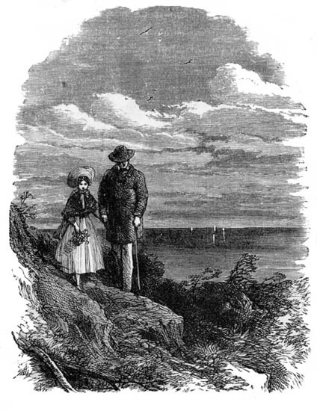THE FIRST WALK BY THE SEA-SIDE.
"'Now we must go, dear,' said Uncle John. 'Strange, that of all the works of creation none make such a wonderful impression as the first sight one gets of the sea.'
"'Do you ever walk this way, uncle?' I inquired, as we turned into another path that led to Mrs. Berkley's mansion.
"'Sometimes; indeed, it is a favourite walk of mine,' he replied. 'I like to come and sit just at that point where you stood. Your aunt used to be very fond of that walk also.'
"'It will be such a nice place to see her in the clouds,' I said, but a little timidly, for this was the first time he had ever mentioned her name, and he had sighed heavily when he did so.
"'Why, what do you mean, Lily?' he asked abruptly, and, as I fancied, a little sternly.
"'When my sister Alice died, uncle, I was so sad and lonely without her,' I replied. 'Mamma was so busy nursing my brother William, that I had to amuse myself the best way I could; and so I used to sit by the window gazing up into the sky; and when the clouds came sailing past, I used to fancy I saw sister Alice in the very white ones. Nurse told me she is now clothed in white, and I knew Alice would weary to see me too; and I used to think God, who is so good and kind, would perhaps let her hide in the white clouds.'
"Uncle John drew me closer to him, and instead of reproving me for my fancy, he kissed me, as he said, 'Poor child, poor little town-bred child, if you had had flowers, and birds, and butterflies to chase, it would have been better for you. I think we shall have to write and ask mamma to send us Willie here also.'
"'Oh, that would be so nice!' I exclaimed. 'Willie would enjoy it so much! But see, uncle, there are some children with a donkey coming this way.'
"'These are some of the young people I told you were living with Mrs. Berkley.—Hollo!' cried uncle, signalling to the children, who came running down the path as fast as they could the moment they heard the rector's voice. There was a little girl on the donkey's back, and two boys by the side of it, with a stable-lad to see that she did not tumble off.
"'We were so glad when you called, sir,' said the oldest boy. 'Aunt Berkley said we might go and meet you, but we thought you would come by the highway.'
"'Yes; but this little niece of mine had never seen the sea, and I wanted to let her have her first view from the Bluff Crag.'
"'Then you have never been down to the beach?' said the little girl. 'We must get aunt to allow us to go there after dinner. It is such a delightful walk;—isn't it, sir? And you needn't be afraid to trust her with us, for we take Natilie when we go, and she is so careful.'
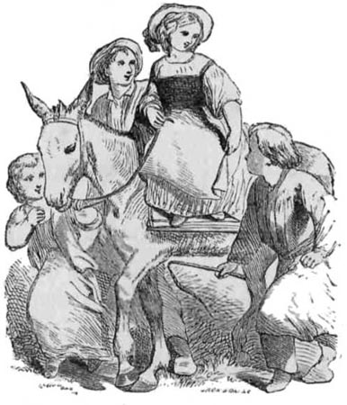VEA ON HER DONKEY.
"'And who is Natilie?' inquired Uncle John, lifting the little girl from the donkey at her request.
"'Oh, Natilie is our French maid, and she is so nice; even the boys like Natilie.—But what is your name, please?' she continued, turning to me. 'Mine is Vivian Berkley, but the boys and all my friends call me Vea.'
"'My name is Lilian, but I am called Lily at home—Lily Ashton,' I replied.
"'Then I shall call you Lily too, may I not?' she said, looking up into my face with a kindly smile, and taking my hand, while her beautiful blue eyes sparkled. 'I am so glad you have come, dear Lily,' she continued. 'I do want a companion like you so much!'
"'Do you find the boys unsocial, then, Miss Vea?' inquired Uncle John.
"'Oh no, sir,' she replied; 'but they are boys, and you know girls are not allowed to do exactly what they do, so I am often alone.'
"'And what do you do when you are alone?' said Uncle John, evidently amused with the precise though sweet tone of voice of little Vea.
"'I play with my doll Edith, and I read my story-books, and I talk to Natilie. Do you know, sir,' she said, letting my hand loose and taking my uncle's as we mounted up the steep slope to the road above, while the donkey was led round by another way, followed by the boys, 'poor Natilie, when she came to stay with us, could not speak a word of English, and she was so sad. And the boys used to laugh at her, and so did I sometimes, till Aunt Mary, in whose house we were living, told us that if we only knew poor Natilie's sad story we would be so sorry for her, that, instead of laughing, we would be apt to cry.'
"'And what was the story?' inquired the rector.
"'Oh,' said Vea, laughing, 'Aunt Mary was so cunning about it, she wouldn't tell us a word, but said we must learn our French very fast, and that then Natilie would tell it for herself; and as Aunt Mary said it was far more interesting than any we could read in our story-books, we did try to understand what she said to us very hard indeed. But we haven't heard the story yet; only we never laugh at Natilie now, for we have made out little bits of it, and we know the chief reason why she is sad is this: her husband is a very bad man, and he ran away and left her, and carried off her two little children, and she cannot find them.—But will you please walk into the garden, sir?' she continued, opening a side gate. 'Aunt said we might show you the new rustic table as we came along.'
"Patrick, the eldest boy, who had run on before, joined us just as we came up to the arbour, where a neat round table stood, having curious feet made out of the rough branches of a tree; the top had been polished, and painted with varnish, and looked very splendid indeed. But the quick eyes of Vea soon detected an ugly scar on the bright surface, as if some boy had been attempting to cut out a letter upon it.
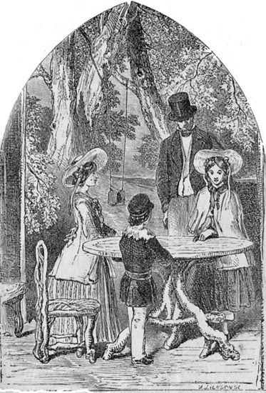THE NEW RUSTIC TABLE.
"'Oh dear, who has done this?' cried little Vea, while Patrick turned away with blushing face. 'Patrick, this is a wicked action; do you know anything about it? Now be careful; think well before you answer.'
"Uncle John could scarcely keep from smiling at the way Vea spoke, and the anxious manner shown towards her brother. 'O Patrick,' she exclaimed, 'if you did this, it is very wicked; you must go and tell aunt about it at once.'
"Instead of answering, however, Patrick set off at a gallop, and disappeared behind some bushes, leaving Vea standing looking after him with glistening eyes. 'What is to be done now?' she said, as if to herself; 'it is so difficult to get Patrick to own a fault, and I fear he will lead Alfred into more mischief. O mamma, mamma, I wish you had never left us! I do try to keep the boys right, but they are so wild sometimes.'
"'You cannot do more than your best, my child,' said my uncle, laying his hand tenderly on her bowed head. 'Would you like me to speak to your aunt for Patrick?'
"'Oh no, sir, thank you very kindly,' she said, drying her eyes hastily; 'Patrick must confess the fault himself, if he has done it. Aunt Berkley is so good-natured, that I am sure she would excuse him if you asked; but that would not be safe for Patrick,—he forgets so soon, and will be at some other mischief directly. Aunt Mary warned me about this very sort of thing.'
"'Well, I am sure he ought to be a good boy, having such a kind, good little sister to look after him.'
"'Please, sir, don't say that,' said Vea, the tears coming to her eyes again; 'I don't deserve such praise; for the reason why Aunt Mary told me of Patrick's faults was, she wished to point out my own, and she knows I am so lazy, and don't like to check the boys, lest they should call me "Goody;" but Aunt Mary said I ought to look after them,—that a good word costs nothing; at anyrate, if I had only to bear being called a harmless name, it was but a very small cross, compared to the evil I might cause by allowing the boys to play mischievous tricks.'
"'That is right, my dear child,' said Uncle John; 'we must do our duty, however hard it may be; and though a good word in one sense costs nothing, still we all know it sometimes costs a good deal, and is a difficult matter, to a great many people.'
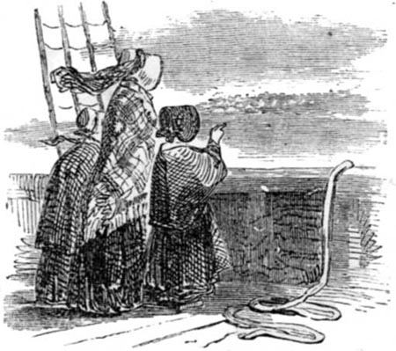ON BOARD THE STEAMER.
"To Vea's astonishment, instead of her Aunt Berkley letting her brother off easily, when she found out about the mischief done to the table, she was so very angry that she would not allow him to join the party that afternoon in the excursion in the steamer. While she pointed out the various objects of interest to Vea and myself, seeing that poor Vea was depressed in spirits—her kind heart suffering extremely when her brothers fell into error—Aunt Berkley whispered, 'You are not vexed with me, dear child, for punishing Patrick? If he had owned the fault, I would have forgiven him; but he was so stubborn, and would not even speak when spoken to. Alfred is so different.'
"'Oh no,' said Vea quickly; 'I am only sorry that he was so naughty and required the punishment;' but, as if afraid she was condemning her brother, she added, 'Patrick has a warm, affectionate nature, aunt; if he could only get over his love of mischief he would be a dear, good boy.'
"'Well, my dear, we must try to help him to be good. Boys will be boys, however; though it is necessary to punish them sometimes, else they might get into serious disgrace. We must have another excursion soon, and perhaps the thought of it will keep Patrick from being naughty.'
"On reaching home that afternoon they found the school-room empty; and though Patrick had been told he was to remain in the house till his aunt returned, he was nowhere to be found. Alfred sought for him in all their favourite haunts about the out-houses and garden, but without success. 'I'll tell you where he will be, Vea,' said Alfred, on his return to the school-room from a last hunt in the orchard,—'he has gone to the cave at the Bluff Crag.'
"'Oh, surely not,' said Vea in distress. 'Aunt told us distinctly we were never to go there without leave from her, and then only with some person who knows the coast well. What makes you fancy such a thing, Alfred?'
"'Because, I remember now, he muttered to himself about giving aunt something to be angry for; and he has often been wanting me to go there.'
"'I hope this is not the case, Alfred,' said Vea. 'But perhaps aunt would allow us to go down to the beach with Natilie, to look for him.'
"'I daresay she will,' said Alfred; 'but if you do ask her, don't mention Patrick's name; you needn't be getting him always into a scrape by your tale-telling.'
"'O Alfred, how cruel you are,' said Vea, 'when you know I am always trying to get you boys out of scrapes!' and the tears rose to her eyes.
"'Very well, then, I won't,' said Alfred; 'you are a dear, good little sister, and we do bother you tremendously sometimes. Stay you here, and I will ask aunt to let us go to the beach.'
"Alfred soon returned, stating that his aunt had said Yes at once to his request; 'But,' he added, laughing, 'I think she did not know very well what she was saying, she was so busy talking to the rector.'
"Natilie was quite willing to accompany us, and very soon we were down on the beach; but whichever way we looked we could not see any trace of the missing Patrick. All of a sudden Alfred gave a shout, and pointed in the direction of some great high rocks upon which stood a light-house.
"'See, Vea, there is Wild Dick running upon the rocks!' cried Alfred excitedly.
"'Where?' said Vea, standing on tip-toe, and straining her head forward towards the place Alfred was pointing out.
"'I see von boy,' said Natilie, in her strange broken English. 'Him not be Master Patrick. I know him now for that same wicked boy Mrs. Berkley forbid you speak to.'
"'But I tell you Patrick is with him,' said Alfred, showing he knew more about his brother's movements than he had owned at first. 'Dick offered to help him to find some sea-birds' eggs, and they have gone off to get them now.'
"At this moment the boy called Dick observed us, and as soon as he did so he began to make signs in a most excited manner to us to hasten.
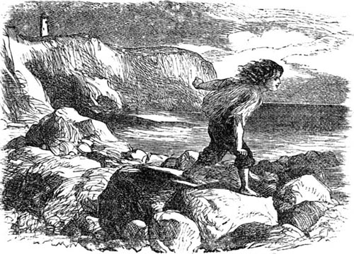WILD DICK.
"'There has been some accident to Master Patrick, I much fear,' said Natilie, beginning to run. 'Oh, when will that boy be good?'
"On coming closer to Dick, it soon became evident that an accident had really happened; and in a few moments more they learned that the unfortunate Patrick, in climbing the rocks, had lost his footing, and had fallen down from a considerable height.
"'I think he's broken his leg, miss,' said Dick to Vea. 'And how he is to be taken out of that 'ere hole he has fallen into, is what I'd like very much to know.'
"'Do show us where he is, Dick,' said Vea. 'Oh, be quick; he may die if his leg is not attended to at once!'
"It was no easy matter to scramble over the stony beach to the place where Patrick was lying; and rather a pitiable sight it was to see him with his leg doubled under him, and with a face so very pale that it was no wonder Vea cried out with pure horror, for she evidently thought he was going to faint, or die altogether, perhaps.
"'Oh, what shall we do?' cried Vea. 'How are we to get him up? and how are we to get him carried home?'
"'I would not have you distress yourself so, Miss Vea,' said Natilie. 'I think I can get him out of this difficulty, with very little patience, if we could get him carried home.'
"'If you get him out of the hole he has fallen into,' said Dick, 'I will manage the rest.'
"'But how can you carry him over such a rough beach?' asked Alfred.
"'I will get the boat from my grandfather,' replied Dick, 'and we can row him round to the harbour, where the men can help us up to the house with him.'
"'Oh yes, that will be the plan,' said Vea. 'Do run, like a good boy, and get the boat; I am sure your grandfather will be very glad to lend it to us, for Patrick was always a favourite with him.'
"'And I know somebody who is a greater favourite than even Master Patrick,' replied Dick, smiling, before he hurried away towards his grandfather's house.
"Very soon, though it seemed a long time to Vea, Dick was plainly seen shoving out the boat from the shore, with the assistance of two boys, who then jumped in and rowed it round as close to where Patrick lay as they possibly could.
"Natilie had by this time managed to get Patrick up out of the sort of hole he had fallen into, and by our united efforts we at last succeeded in getting him into the boat, where we all helped to support him, as he had fainted away again. It was considered advisable to row to Dick's grandfather's house for the present; and accordingly the boat was steered for a cove, up which the tide carried us.
"The hut where Dick's grandfather lived was a very poor one, built mostly of turf, and thatched with rough bent or sea-grass. The chimney-can was made with an old barrel, which stood the blast and served better than an ordinary one would have done at such a stormy part of the coast. One or two fishing-boats lay at the rough pier or jetty old Dick had constructed, the men belonging to which were earnestly engaged preparing their nets for going to sea that evening; while a number of boys were busy sailing miniature boats in a small pool left by the last tide. No sooner, however, did they hear the shouts of their companions in our boat, than they left their sport, and hurried down to lend a hand in pulling in the boat to a place of security.
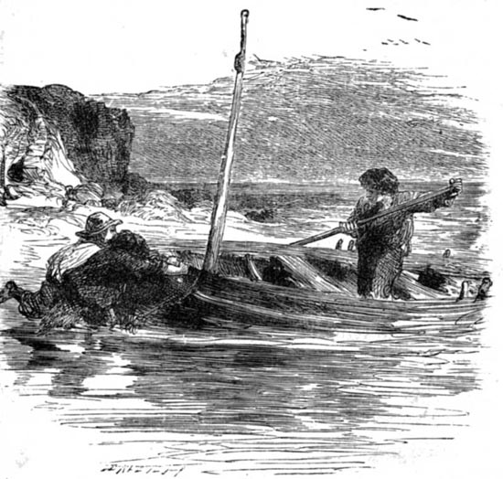FETCHING THE BOAT.
"'Has grandfather come back from the town, Jack?' cried Dick to a rough-looking boy, the tallest of them all, and who had carried his model boat in his arms, instead of leaving it as the others had done theirs.
"'No, he ha'n't,' replied Jack; 'and, what's more, it's likely he won't be for some time either; for I hears Tom Brown saying to Tim that my father would be late to-night, and I knows your grandfather is to keep him company.'
"'Then what's to be done now, miss?' said Dick. 'I had been thinking grandfather, who knows all about sores, seeing as he was boatswain's mate aboard a man-o'-war, might have been able to put young master's leg to rights.'
"'Oh no, Dick, that would never do,' said Vea; 'we must get him ashore and laid in your grandfather's bed, and somebody had better run up to tell aunt of the accident, and get her to send for the doctor at once.'
"While Natilie prepared the bed in the old fisherman's hut, Patrick was being carried by the men who had been summoned from the boats. The poor boy was still in a fainting state, and it was not till after he had been laid on the bed that he opened his eyes and showed signs of consciousness. 'Oh, where am I?' he uttered; but even this exertion was too much for him, and he became insensible once more.
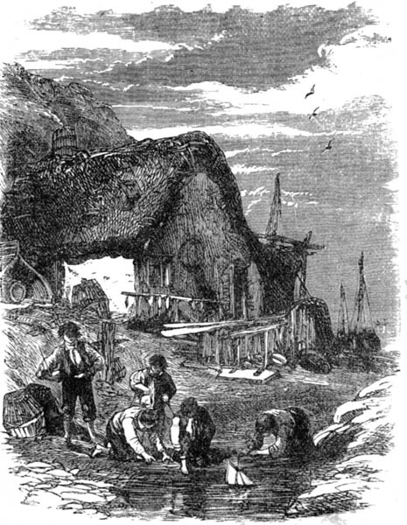WILD DICK'S HOME.
"'It's a bad break, this,' said one of the men to his fellow; 'I shouldn't wonder, now, if he had to lose his leg altogether!'
"'Oh, please don't speak of it,' said Vea, her face becoming ghastly pale. 'Do look out again, Lily dear, and see if Alfred is coming with the doctor.'
"Yes; there he was at last, running at a break-neck speed down the steep and rocky bank to the beach, while the doctor was distinctly seen high overhead on the regular path, coming very quickly too. Indeed, though he had taken the longest road, and did not seem to hasten like Alfred, he was only a few minutes behind him, and showed no signs of heat and over-exertion.
"'Heyday, this is a pretty business,' said Dr. Blyth cheerily. 'What's this you've been about, Miss Vea? breaking your brother's leg, eh?' All this time he had been unrolling a case of formidable-looking instruments, taking off his coat, and getting fresh water brought, and bandages prepared with the help of Natilie. When these were ready, he turned to look at his patient, and bidding every one leave the hut but the two fishermen and Natilie, he shut the door against them himself, and secured it firmly.
"'Oh, please, doctor, let me stay,' Vea had said pitifully. 'I'm sure Patrick would like me to stay.'
"'I'm sure of that too,' said the doctor kindly; 'but you shall have plenty of nursing by-and-by: don't be afraid, I mean to engage you as my chief assistant. Meanwhile, my dear, trust me for knowing what is best for you and for your brother, and take yourself off to the beach there. Come, Miss Lily,' he continued, turning to me, 'you take your friend down to the beach, and keep her there till I call you. Remember, you are not to leave the rock there till I call you, Miss Vea.'
"'Oh dear, dear, it does seem hard,' said Vea, when we were seated under the rook, 'to leave Patrick in the hands of strangers. And yet, Dr. Blyth is such a good, kind man, I'm sure he won't give him unnecessary pain.'
"'Would you like me to read a story to you, dear Vea?' I inquired, opening a book I had brought out with me. 'It might help to pass the time away.'
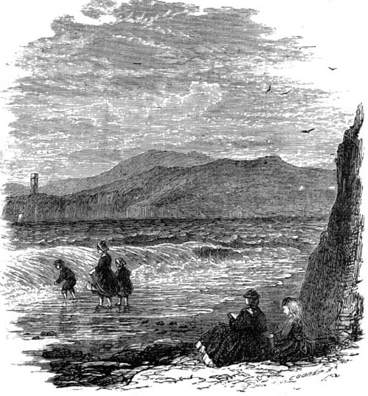DOWN ON THE BEACH.
"'Thank you, Lily,' said Vea; 'but I feel as if I couldn't listen to anything; and yet, if I sit here I shall go mad with the suspense.'
"'Come, then, take a walk along the beach,' I replied; 'we will be within reach of the doctor's voice quite as well. I know he will take some time to set the leg; for when our stable-boy, Reuben, got his leg broken, the doctor took a long time to set it.'
"'And did Reuben's leg get well again—quite well, I mean?' inquired Vea earnestly; 'was he able to walk with it as he did before?'
"'Oh yes; he could use it quite as well as before,' I replied. 'Indeed, papa used to say Reuben was quicker at going a message after the accident than before.'
"'Oh, I am so glad to hear that,' said Vea, sighing. 'I do hope it will be the same with Patrick. Poor Patrick! Aunt Mary has so often said he would need to get some severe lessons to make him think. She was always telling him that he would find out the path of transgressors is hard, instead of pleasant, as he seemed to fancy. I don't think there is such a miserable girl as I am in the world?' And here Vea began to cry.
"After comforting her as well as I could, she was at last prevailed upon to take a short walk along the beach in the direction where some children were playing. As we walked along I told her that my mother often said, when we fancied ourselves ill-used and very unhappy, if we looked about us we would generally find that there was somebody even more miserable than we were ourselves. By this time we had come up to the children, and found three of them in earnest conversation. We were not long in discovering that the youngest was in evident distress, and her companions were listening to her words with deep interest.
"'I wouldn't stand it, if I were you, Polly,' said the eldest girl, who was standing in front of the group.
"'But what can I do, Martha?' replied the girl, rocking herself to and fro, and weeping afresh.
"'Do? I would run away,' replied the other. 'I would go into service, or beg my bread from door to door, rather than bear what you have to bear.'
"'But don't you think you had better speak to teacher, Polly?' said the other girl softly, looking from under her sun-bonnet with great dreamy-looking blue eyes; 'I wouldn't do anything rash before speaking to teacher. You remember what she said to us last Sunday, that all our trials were sent from our Father in heaven.'
"'Yes, Rachel, I heard her say that,' replied Polly; 'and I try to think about it; but oh! my step-mother would make anybody angry; and then my temper rises, and I speak out, and then I am beaten. I wouldn't mind that, however, if she would only beat me; but when I see her raise her hand to strike little Willie, who never was angry in his life, but was always gentle and good—always, always.'
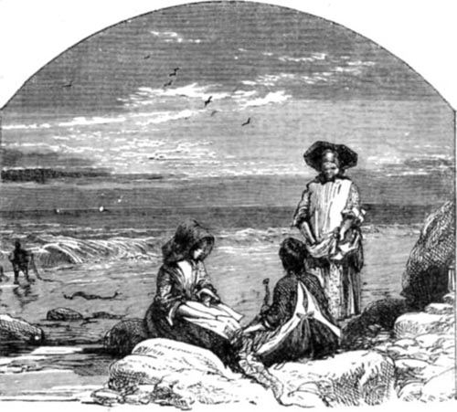POOR POLLY.
"'Is there anything I can do for you, little girl?' said Vea, stepping forward, forgetting for the time her own trouble while witnessing the distress of another. 'Why does your companion want you to run away?'
"'It's to escape from her step-mother, miss,' replied the girl called Martha. 'She uses her shameful, she do, and all for what? Because Polly's father made so much of her afore he was lost.'
"'And was your father lost at sea, Polly? Oh, how dreadful!' said Vea, seating herself on the stones beside her. 'And have you no mother of your own?'
"'No, miss; mother died when Willie was a year old,' said Polly.
"'And do you remember her quite well?' asked Vea.
"'Oh yes, quite well, miss. It was a terrible night that, just before she died. Father was away to the town for some tackle, and I was left all alone with her and Willie. She hadn't been very well for some weeks, but nobody thought she was going to die. Even the very doctor had said that morning so cheerily to father she would weather through. She had been lying sleeping with Willie in her arms, but a sudden squall shook the door, and made it and the window-frame rattle, and that startled her, and she wakened. Then I couldn't help seeing she was much worse; and I tried to keep from crying, for she seemed wild-like, and the doctor had said she was to be kept quiet. Then she looked up in a moment, and said, "Polly, promise me you'll look after Willie when I die. Never let any harm come to Willie, mind that; and take care of father, but look well after Willie." She never spoke again, not even to father, who came in soon after, and cried like a baby over her. She just opened her eyes once, and looked at him with a smile, and tried to push Willie over to him, and then she died. How good father was to us then! He used to take Willie down to the beach with him while I made the house tidy and got the dinner; and he made Willie a fine boat, and dug out a place for him to sail it in; and oh! but we were happy then!'
"'I don't think your father would have been lost if it hadn't been that step-mother of yours,' said Martha angrily. 'I can't a-bear her, I can't.'
"'Oh, don't say that, Martha. It was God who took father,' said Polly, in a low whisper. 'Didn't you hear the rector saying it was God's will to send the storm that night?'
"'Yes,' said Martha; but if your step-mother had only bade your father stay at home, as all the other men did, he never would have been lost. Didn't old Joe Gafler warn them there was a squall a-coming! but no, she is so grasping, she wanted the money for the fish, and she let him go. It was a shame!'
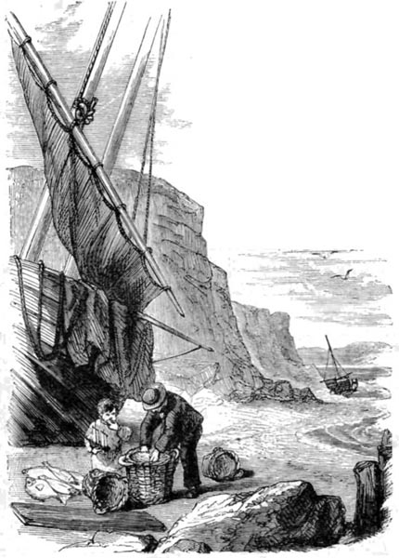LITTLE WILLIE AND HIS FATHER.
"'But father often says the boat may be found yet,' said Rachel; 'and you know even old Dick says the thing is likely.'
"'Well, if so be's it should happen that Will Dampier comes to land again, I hope he'll know how his Polly has been treated when he was away,' said Martha.
"'Oh, I wouldn't mind for myself not one bit,' said Polly. 'It's when she strikes Willie that I can't bear it; and I somehow think Willie is not so well this last week.'
"'Then you mustn't think of running away, Polly,' said Vea. 'Wasn't that what Martha was urging you to do? If you went away, who would take care of Willie? Do you know, I have a brother I am very anxious about too, Polly?' said Vea. 'He is lying in Dick's cottage, with his leg broken, and the doctor is setting it while we are waiting out here.'
"'Oh, I am very sorry indeed, miss,' said Polly, forgetting her own troubles in turn. 'Is that the young gentleman who is living with Mrs. Berkley?'
"'Yes, Polly,' said Vea. 'Mrs. Berkley is my aunt.'
"'He's a very kind young gentleman, miss. Is there anything I could do for him, miss? I should like to do something so much, for he helped me more than once.'
"Vea naturally looked a little surprised, for Patrick was so often in trouble, that it was rather astonishing to hear any one praising him.
"'I don't think it could be my brother Patrick,' said Vea.
"'Oh yes, miss, that was his name,' said Polly. 'He told me his name was Patrick.'
"'And what did Patrick do for you?' said Vea, looking much pleased.
"'I was playing with Willie one day at the harbour, and young Dick was showing me a great anchor some of the men had left on shore for a new boat they were going to build, when my step-mother called from the cottage door, and bade me take the ropes and carry home the drift-wood she had been gathering all the morning. Dick said as how he was sorry he couldn't go to help me, as he had to go out in his grandfather's boat that afternoon; and so, after leaving Willie beside old Dick, I took the ropes and went down on the beach. My step-mother had called after me I was to drag them in three bundles, but they were so heavy that I had to separate the first one into two; and for doing this she beat me. I was going back to the next one, crying a good deal, for I was wishing I could go to my own mother and to father, when a boy jumped up from behind a stone, and asked me why I was crying; and so I told him. And when he heard it, he called my step-mother some hard names; and then says he, "Are you the little girl young Dick helps when he has any spare time?" And when I answered "Yes," he says, "Well, then, give me the ropes and I'll help you, for Dick is away to-day." I couldn't help saying that dragging drift-wood wasn't fit work for a gentleman; but he just laughed, and said there were lots of people would be glad to know Patrick Berkley was so usefully employed.'
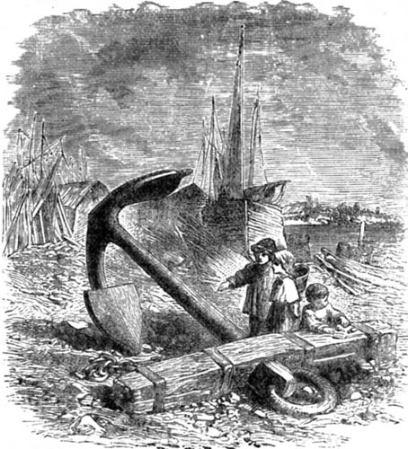THE ANCHOR.
"'And did he drag the wood for you?' said Vea, the tears standing in her eyes.
"'That he did, miss. And whenever he sees me carrying a heavy load along the beach, he just slips up to me, and, without saying a word, takes it out of my hand. And then if he sees any of the boys frightening me, he won't let them. I was so sorry, miss, for the cut he got on his eye; that was from wild Joe throwing a stone at him when he was carrying my basket for me round the Bluff Crag.'
"'You have no idea how happy you have made me, Polly,' said Vea. 'Aunt Mary always says there is a great deal of good in Patrick, only his love of mischief sometimes chokes the good seed. It is very strange he never lets us see him doing a kind or a generous action.'
"At this moment Natilie opened the cottage door and called to her young mistress to come up. I waited by the beach, and taking off my shoes and stockings, waded into the cool water. The girls were much amused at my delight, and I may say terror also, as, looking down into the clear blue water, I saw various small fishes darting in and out among the stones; and even Polly forgot her angry step-mother at home, and screamed with laughter at my sudden fright when a small crab seized hold of my great toe, and hung tenaciously to it, even when I was far up on the sandy beach.
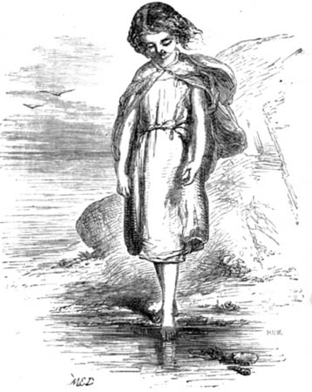BY THE BEACH.
"Then Natilie came and called to me to come up also; and there I found Patrick lying very quiet and still on the bed, and Vea sitting by the side of it holding his hand. It was arranged that I should return to the house with Natilie and Alfred, while Vea remained with her brother till Natilie returned; but just as we were setting out, my Uncle John came down to see after the patient, and I was told I might amuse myself for an hour outside till the maid returned with the articles required by the doctor. I would have liked to have stayed with Vea, but both the doctor and my uncle thought that as the cottage was so small, the fewer there were in it the better for Patrick.
"'I would like to get home,' said poor Patrick in a faint voice. 'Couldn't I be carried home, sir?' he pleaded, turning to the doctor.
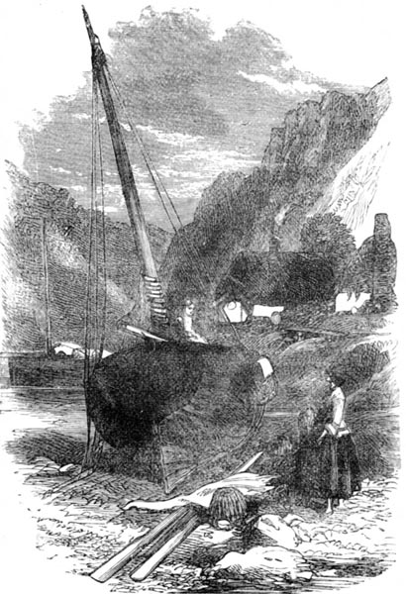DOWN AT THE COVE.
"'Not for some days, my boy,' replied the doctor kindly. 'If you lie very still, and attend to orders, we shall see what can be done for you then.'
"But when the doctor had gone, Vea came slipping out, and bidding me follow her, went round to where some boats lay moored. A ladder was placed against the side of one of these, and up this Vea mounted before I knew what she was going to do. 'I feel sure,' she said, looking over the side of the boat to me, as I stood on the beach below, 'if we could only get Patrick hoisted up here, we might get him taken home quite safely.'
"'Ah, but I don't think the doctor will allow you to do that,' I replied; 'I fear he must remain here for some weeks.'
"'He seems very anxious to get home, poor boy. I cannot make it out,' said Vea. 'He says he will tell me the reason once he finds himself in his own bed at Aunt Berkley's. I wonder who this boat belongs to.'
"'Polly said it belonged to Martha's father,' I replied; 'she told me so just before they left me to go home.'
"'Polly, I hope, has quite made up her mind not to run away,' said Vea.
"'Oh yes, I think she has given up that idea; indeed, I heard her say to Rachel she would try to bear it a little longer.'
"'There is Dick returned already,' said Vea; and she scrambled out of the boat, and ran down to the beach to meet Dick, who was coming from the doctor's house with a basket containing medicines for the sick boy.
"'Oh, you are a good boy, Dick,' said Vea. 'How fast you must have gone!'
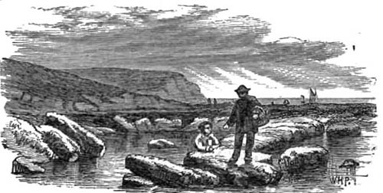DICK RETURNING WITH THE MEDICINE.
"'Well, yes, miss, I did go fast,' said Dick, pleased with Vea's speech apparently. 'I went by the beach, the tide being out, and it is nigher that way by a good mile. I would go faster than most folks for the young master.'
"'Why, has Patrick been kind to you too, Dick!' said Vea, in much surprise.
"'That he has, miss,' said Dick gratefully. 'When I lost grandfather's knife, didn't he buy me a new one with the new half-crown his aunt gave him to spend at the fair! And didn't he let grandfather think he had broken the glass in the window, when all the time it was me, and nobody else! And hasn't he often and often brought me a bit of his own dinner tied up in his handkerchief, or a pie he would find lying handy in the pantry, when he knowed I'd had nothing for my dinner that day at all!'
"Vea said nothing, but she evidently thought her brother was a very curious boy, and that she had not understood him at all.
"When Natilie had returned with the things required by the sick boy and his attendants, Uncle John and I set off home, he promising that we would return the next afternoon to inquire after Patrick. The sun was just shedding its last rays of golden light over the sea, lighting it up with a strange lurid light, which, with the stillness of the scene, and the great rocks on the coast, left a strange impression on my mind.
"'And you say you have enjoyed yourself, my dear!' said Uncle John, after we had walked on in silence for some time.
"'Oh, very much indeed, uncle,' I replied. 'I like Vea so much, and Alfred is such a funny boy. Isn't it a pity that Patrick is so fond of mischief, when he seems to have such a kind heart?'
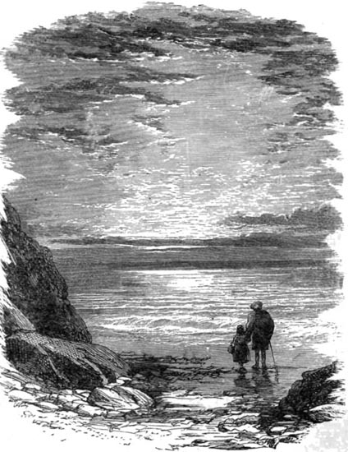GOING HOME WITH UNCLE JOHN.
"'I've always liked that boy Patrick,' said my uncle; 'and, what is more,' he continued, as if to himself, 'I never liked Alfred.'
"'That is very strange, uncle,' I replied; 'he is such a polite boy, and so quiet in the drawing-room. He is so funny too; he nearly set me off laughing at the funny faces he made behind his aunt's back; and he can speak just like her, in that queer low drawling tone.'
"'Exactly,' said my uncle; 'that is the very thing I dislike about him. He has the power of mimicry, and is also able to keep a grave face when others are forced to laugh—a thing poor Patrick is not able to do, and the consequence is he gets into sad disgrace for laughing, and, to save his brother, won't tell what he is laughing at. Alfred is a mean boy, for twice I have seen him allow his brother to be punished, when, by simply telling he was the cause of it, the punishment might have been avoided. Now, who do you think was the actual culprit who cut that nice table in the summer-house?'
"'It must have been Patrick, uncle; he never denied it,' I replied.
"'That is the strange thing, dear. Patrick is greatly to blame in this, that he will not tell upon his brother, but is so easy-minded, that, rather than exert himself to make his friends think well of him, he allows every one to suppose that he is the offender; and, as I said before, Alfred is so mean, that, knowing this, he plays the tricks and lets his brother take the blame. A tale-teller is to be despised; but a boy who is so lazy that he cannot say a good word for himself when his character is concerned, is almost as bad.'
"'But how did you find all this out, uncle?' I inquired.
"'Well, I overheard the two boys speaking about it in the shrubbery; and what struck me most was, even when Patrick had an opportunity to reprove his younger brother he did not do so, though a good word costs nothing, and might save his brother much misery in the end. I am half glad he has met with this accident; it will give him time to think.'
"At this moment a boat sailed past, filled with gay company, who waved their handkerchiefs to us, and cheered most lustily. One little girl held up her doll, and made it wave its hat to Uncle John's polite bow, which made them all laugh very much.
"Dolly was very glad to see me again, and said so kindly that she had never spent such a long, dull day, and that she hoped I would not go junketting in a hurry, else she would require to go with me herself. There was no time to tell her all the story of our visit to Mrs. Berkley that night, because a woman came in asking her to go down to the village to see a sick man who had wandered there that day, and had been found lying under a hedge by a field-worker. Then, as it was close to my bed-hour, and I was very tired, Dolly carried me off to my room at once, and when she had seen me safely in bed, went away. The next morning while at breakfast she told me the sick man was apparently a fisherman, but he was so weak he could not give an account of himself. Once or twice he had suddenly become uneasy in his sleep, and had moaned out a name some of the women thought was Polly, but so faintly, that they could not be sure even of that.
"'Oh, it must be Polly's father come to life again,' I cried, starting up and knocking over my basin of milk upon the clean white table-cover. 'Oh, do let me run and tell uncle about it, Dolly; he will know what ought to be done.'
"Uncle John did not like to be disturbed in the morning, but this was an extra case, and after Dolly had heard of the sufferings poor Polly had to endure from her cruel step-mother, she allowed me to go to the study door and tap gently. Uncle John listened very attentively to the story about us meeting the three little girls on the beach, and at once agreed to set out to inquire for the sick man; and proposed, if he was still too weak to answer questions, to go on to the Bluff Crag, and get one of the fishermen from there to come up to look at him. Fortunately, when my uncle arrived the sick man was much better, and though only able to speak a word at a time, understood all the questions that were put to him. It soon became evident that this was indeed Polly's long-lost father. When he was a little stronger he told how the boat that fearful night had drifted away along the coast, and how it at last was dashed up on the rocky beach, and how he had been thrown out into a sort of cave, where there was barely standing room when the tide was full, and how he had lived for days on the shell-fish that he found sticking to the side of the cave, or the eggs he found on the shelves of rock; and at last, when even this scanty supply failed him, and he was nearly mad from the want of water, how he had dashed himself into the sea, determined to be done with his misery. Then he told how, when he came to himself, he found he was lying in a cottage, with a woman bending over him, and a man sitting smoking by the fire, stirring some stuff in a pan. It seemed that this man was a collector of birds' eggs, and, knowing about this cave, he had come down, with the help of a great strong rope tied round his waist, to gather eggs. Great was his surprise when he saw the body of a man floating in the water; but he lost no time in seizing him by the belt, and, with the help of his comrades up at the top, brought him safely to land.
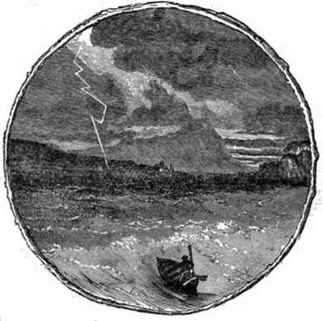OVERTAKEN BY THE STORM.
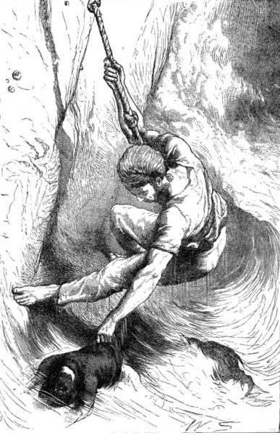RESCUED.
"You can understand how glad Polly was when, that same evening, Uncle John took me with him to tell her of her father's safety. I kept fancying all the way that when she heard the news she would dance and shriek with joy, and clap her hands; but, instead of that, she just sat quietly down on a stool by the fire. What a white face she had, and how her lips trembled! Even Uncle John was struck by her appearance, and must have been afraid the sudden news had been too much for her. 'Come, come, Polly, this will never do,' he said kindly; 'you must set about getting some clothes put up in a bundle, and come away back with me. Father is very impatient to see his little Polly, I can tell you!'
"'Polly again! it's always Polly!" said her step-mother. 'I don't believe he cares a pin about me and my children so long as these two are all right.'
"Uncle John spoke to her very sensibly, as I thought, telling her that her husband's children ought to be as dear to her as her own, for his sake, and that a jealous disposition often led to much misery; but I don't think it made much impression upon her: and I was very glad when Polly appeared ready to start, with her clothes and some for her father also, tied up in a little bundle.
"Some days after, uncle kindly took me to spend the day with Vea. I was delighted to find that Patrick had been removed to Mrs. Berkley's, and had stood the journey very well. He had been carried on a stretcher by some of the fishermen; and they had borne him along so gently that Patrick declared he had never felt the least motion, and thought he had been lying on his bed all the time.
"'I should like to get some flowers so much,' said Vea, after I had arrived. 'Patrick is so fond of flowers; but he likes the wild ones best. He says the hot-house ones smell oppressively, but the wild ones make him comfortable.'
"'Then why can't we get him some?' I inquired.
"'Aunt doesn't like us to go to the wood by ourselves; and Natilie is engaged to-day,' replied Vea.
"'I'll tell you how we will manage it,' I replied, laughing. 'We will ask uncle to go with us.'
"'But do you think he will go with us?' said Vea eagerly.
"'Oh yes, I think he will—I am sure of it, almost,' I said; 'because I heard your aunt telling him she had some important letters to write, and he said he would take a walk in the garden till she was done.'
"Uncle John was very kind, and consented to go with us; and not only so, but took us to the best places, and while we filled our baskets sat reading beside us. Then, when we had picked enough, he told us stories while we rested; and we were very happy. Something he said about a boy he once knew made Vea think of Patrick, for she exclaimed, quite suddenly,—'Oh! do you know, sir, we have found Patrick out at last! When he was lying at the cottage, there were so many poor people came to ask for him, that even aunt became interested; and she made inquiries, and we found that Patrick was in the habit of helping them in some way or other. One old woman told us he actually drew all the stock of drift-wood she has at her cottage, and piled it up there for her.'
"'But how did he manage to do it without you finding him out?' said Uncle John.
"'Oh, he rose and went out very early in the morning,' replied Vea. 'The servants were often complaining of the state of his boots; so, in case they would find him out, he used to leave them in the garden and go without his stockings. And do you know, sir, he was telling me such a sad story about that poor woman, and the reason why he helped her. She has lost her husband and three sons; and then her only child, a little girl, was drowned one day looking for drift-wood on the sea-shore.'
"'That will be Widow Martin then, I suppose!' said my uncle. 'Her story was indeed a sad one.—I am very glad to hear such good accounts of my young friend Patrick.'
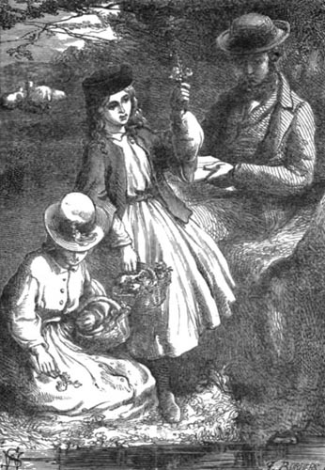GATHERING WILD FLOWERS.
"'And I am glad about it too, sir,' said Vea. 'Aunt Mary will be so pleased; but do you know, I am afraid Alfred has been the bad boy all the time, for since Patrick has been ill he is never done falling into disgrace. Aunt was seriously angry with him; and I overheard Patrick saying, "You see, Alfred, I often told you, you would be found out in the end; I couldn't always take the blame to screen you, so you had better give it up." Isn't Patrick a strange boy, sir?'
"It was a happy day for little Vea when her brother Patrick was able to be wheeled out, by his faithful friend Dick, in the chair his aunt got for the purpose; and I need not say that Patrick enjoyed it very much. I was invited to spend a week with them then, and as the weather was indeed beautiful, we were constantly in the open air. Patrick had always been fond of gardening, and it vexed him to see how his flowers had been neglected during his illness. 'Never mind,' said Dick; 'I bean't much of a gardener, but I'll do my best to set it all to rights, and I'm sure the young ladies there will lend a hand.'
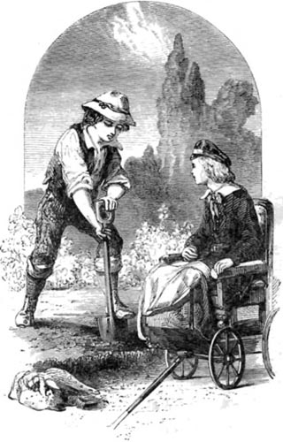DICK TRYING HIS HAND AT GARDENING.
"While Dick dug the ground, Vea and Alfred and I arranged the flowers, much to the satisfaction of every one; and even Alfred, who was not very fond of work, said these busy days were the happiest he had ever spent.
"The day before I left my kind friends, Uncle John came over with a letter from home, saying that I was to return there immediately.
"'Oh dear; I am so sorry,' said Vea. 'I was hoping, sir, she might be allowed to stay for ever so long—at anyrate till all our gardens were finished.'
"'Ah! but there is a pleasant surprise awaiting Miss Lily there,' said my uncle, laughing. 'I am almost certain that even the lovely gardens will be quite forgotten when she sees what it is.'
"'A pleasant surprise, uncle!' I exclaimed. 'What is it?—do tell me, please!'
"'You can't be told till you reach home,' said my uncle, laughing; 'I am bound over to secrecy.' And though I over and over again tried to get him to tell me, he only laughed, as he replied, 'All in good time, Lily; you wouldn't have me break my promise, surely.'
"Dolly was so sorry to part with me, and I was so sorry to leave her, that while we were packing my clothes we cried over the trunk.
"'I wouldn't mind your going, miss,' said Dolly, 'if I thought you would remember me sometimes; but I'm thinking, now that there is a new—— Oh dear, dear,' she cried; 'I was just about to let the cat out of the bag, and what would your uncle have said to that, I wonder!'
"It was plain now that Dolly knew of the pleasant surprise that was waiting for me at home, and the thought of it helped me to be less sorry to part with her and kind Uncle John and all the pleasant things at the rectory. All the way home I kept thinking what it could be. A new doll, perhaps, that grandmamma was to send for my birth-day present; but then my birth-day did not come for weeks yet. A work-box lined with rose-pink, perhaps; but that was to arrive when my sampler was finished—and oh, what a large piece was still to be sewed. I tired myself trying to think, and at last gave it up in despair.
"Of all the things I had thought of, it never came into my head to expect a new baby-sister; but so it was. When I entered the parlour, and was rushing up to fling myself into my mother's arms, what was my surprise to find a lovely baby—the very thing I had been wishing for—yes, actually a baby-sister.
"I don't think I was ever so happy in my life as at that moment, when I was allowed to take the baby in my lap and examine her tiny fingers and toes; and when she smiled in my face, and seemed to be pleased with her big sister, I actually cried, I was so happy. While I was sitting holding baby in this way, my father returned home with Willie, my brother, and such fun and laughing we had, to be sure! But I must own I did feel a little vexed when papa one day said to me, a few weeks after I had returned home, 'Well, Lily, now that you have got such a fat baby sister to carry about, you will have to lay aside your dolls.'
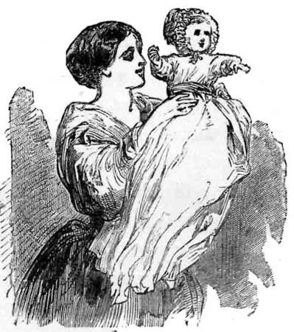MY BABY-SISTER.
"I was very sorry, for I loved my dolls exceedingly; they had been my dear companions and friends for so long. But I knew papa scarcely approved of me playing so much with them, and fancied I might be more usefully employed. I took out my last new doll, Eva, for a walk that afternoon, feeling somehow that she must be laid away in a drawer till baby grew up, when she should have her to be her faithful companion. Stepping out at the side gate into the lane to look for Willie, who had gone to the post, I found an old woman sitting down to rest. After speaking to her for a minute or two, I discovered, to my great delight, that she was the mother of Will Dampier, and the grandmother of Polly. She had just come from the Bluff Crag that very day, where she had been to see her son; and she told me that the last thing she saw, in looking back from the bank above, before turning into the main road, was her son with his crab-basket on his back, and Master Patrick Berkley alongside of him.
"'Oh, I am so glad to hear this,' I replied; 'that shows Patrick's leg must be quite well and strong again. And how are Miss Vea and Alfred? did you see them also?"
"'No, miss,' said the old woman, 'I didn't see them. The young lady and her brother have gone to stay with another aunt at some distance off; but Master Patrick is to remain with Mrs. Berkley all the winter. I'm sure there's more than my son and Polly were glad indeed to hear this, for he is a good friend to the poor, and does many a good action to help them when he thinks as they are frail.'
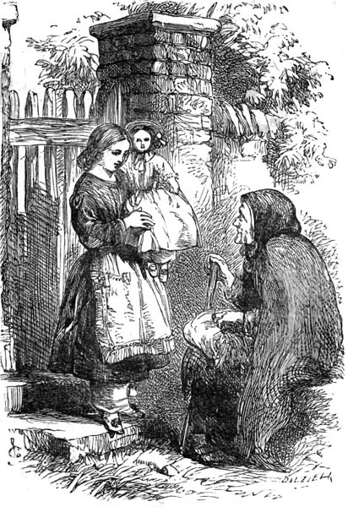MEETING POLLY'S GRANDMOTHER.
"After resting for some time by the kitchen-fire, Polly's grandmother went away, not without promising to come in again if ever she was passing that way when going to see her son.
"That visit was the beginning of many, and very many pleasant days I afterwards spent at the Bluff Crag Rectory. But it is near your bedtime, my dears, and I must stop for the present, and send you to bed," said Mrs. Lincoln.
"Oh! do tell us some more, mamma," pleaded Robert. "I want you to tell us again of those cousins of Vea Berkley's who came from India, and you haven't even mentioned their names."
"All in good time, my dears," said Mrs. Lincoln, laughing; "that is only the beginning of the Bluff Crag stories. It would never do, you know, to have them all told at once. We shall have the story of Vea and her cousins another time, never fear;" and with this promise the children had to be content, and say "Good-night."
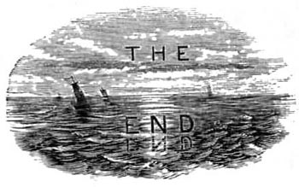
***END OF THE PROJECT GUTENBERG EBOOK BLUFF CRAG***
******* This file should be named 21636-o.odt *******
This and all associated files of various formats will be found in:
http://www.gutenberg.org/2/1/6/3/21636
Updated editions will replace the previous one--the old editions will be renamed.
Creating the works from public domain print editions means that no one owns a United States copyright in these works, so the Foundation (and you!) can copy and distribute it in the United States without permission and without paying copyright royalties. Special rules, set forth in the General Terms of Use part of this license, apply to copying and distributing Project Gutenberg-tm electronic works to protect the PROJECT GUTENBERG-tm concept and trademark. Project Gutenberg is a registered trademark, and may not be used if you charge for the eBooks, unless you receive specific permission. If you do not charge anything for copies of this eBook, complying with the rules is very easy. You may use this eBook for nearly any purpose such as creation of derivative works, reports, performances and research. They may be modified and printed and given away--you may do practically ANYTHING with public domain eBooks. Redistribution is subject to the trademark license, especially commercial redistribution.
*** START: FULL LICENSE ***

THE FULL PROJECT GUTENBERG LICENSE
PLEASE READ THIS BEFORE YOU DISTRIBUTE OR USE THIS WORK

To protect the Project Gutenberg-tm mission of promoting the free
distribution of electronic works, by using or distributing this work
(or any other work associated in any way with the phrase "Project
Gutenberg"), you agree to comply with all the terms of the Full Project
Gutenberg-tm License (available with this file or online at
http://www.gutenberg.org/license).

Section 1. General Terms of Use and Redistributing Project Gutenberg-tm
electronic works

1.A. By reading or using any part of this Project Gutenberg-tm
electronic work, you indicate that you have read, understand, agree to
and accept all the terms of this license and intellectual property
(trademark/copyright) agreement. If you do not agree to abide by all
the terms of this agreement, you must cease using and return or destroy
all copies of Project Gutenberg-tm electronic works in your possession.
If you paid a fee for obtaining a copy of or access to a Project
Gutenberg-tm electronic work and you do not agree to be bound by the
terms of this agreement, you may obtain a refund from the person or
entity to whom you paid the fee as set forth in paragraph 1.E.8.

1.B. "Project Gutenberg" is a registered trademark. It may only be
used on or associated in any way with an electronic work by people who
agree to be bound by the terms of this agreement. There are a few
things that you can do with most Project Gutenberg-tm electronic works
even without complying with the full terms of this agreement. See
paragraph 1.C below. There are a lot of things you can do with Project
Gutenberg-tm electronic works if you follow the terms of this agreement
and help preserve free future access to Project Gutenberg-tm electronic
works. See paragraph 1.E below.

1.C. The Project Gutenberg Literary Archive Foundation ("the Foundation"
or PGLAF), owns a compilation copyright in the collection of Project
Gutenberg-tm electronic works. Nearly all the individual works in the
collection are in the public domain in the United States. If an
individual work is in the public domain in the United States and you are
located in the United States, we do not claim a right to prevent you from
copying, distributing, performing, displaying or creating derivative
works based on the work as long as all references to Project Gutenberg
are removed. Of course, we hope that you will support the Project
Gutenberg-tm mission of promoting free access to electronic works by
freely sharing Project Gutenberg-tm works in compliance with the terms of
this agreement for keeping the Project Gutenberg-tm name associated with
the work. You can easily comply with the terms of this agreement by
keeping this work in the same format with its attached full Project
Gutenberg-tm License when you share it without charge with others.

1.D. The copyright laws of the place where you are located also govern
what you can do with this work. Copyright laws in most countries are in
a constant state of change. If you are outside the United States, check
the laws of your country in addition to the terms of this agreement
before downloading, copying, displaying, performing, distributing or
creating derivative works based on this work or any other Project
Gutenberg-tm work. The Foundation makes no representations concerning
the copyright status of any work in any country outside the United
States.

1.E. Unless you have removed all references to Project Gutenberg:

1.E.1. The following sentence, with active links to, or other immediate
access to, the full Project Gutenberg-tm License must appear prominently
whenever any copy of a Project Gutenberg-tm work (any work on which the
phrase "Project Gutenberg" appears, or with which the phrase "Project
Gutenberg" is associated) is accessed, displayed, performed, viewed,
copied or distributed:

This eBook is for the use of anyone anywhere at no cost and with
almost no restrictions whatsoever. You may copy it, give it away or
re-use it under the terms of the Project Gutenberg License included
with this eBook or online at www.gutenberg.org

1.E.2. If an individual Project Gutenberg-tm electronic work is derived
from the public domain (does not contain a notice indicating that it is
posted with permission of the copyright holder), the work can be copied
and distributed to anyone in the United States without paying any fees
or charges. If you are redistributing or providing access to a work
with the phrase "Project Gutenberg" associated with or appearing on the
work, you must comply either with the requirements of paragraphs 1.E.1
through 1.E.7 or obtain permission for the use of the work and the
Project Gutenberg-tm trademark as set forth in paragraphs 1.E.8 or
1.E.9.

1.E.3. If an individual Project Gutenberg-tm electronic work is posted
with the permission of the copyright holder, your use and distribution
must comply with both paragraphs 1.E.1 through 1.E.7 and any additional
terms imposed by the copyright holder. Additional terms will be linked
to the Project Gutenberg-tm License for all works posted with the
permission of the copyright holder found at the beginning of this work.

1.E.4. Do not unlink or detach or remove the full Project Gutenberg-tm
License terms from this work, or any files containing a part of this
work or any other work associated with Project Gutenberg-tm.

1.E.5. Do not copy, display, perform, distribute or redistribute this
electronic work, or any part of this electronic work, without
prominently displaying the sentence set forth in paragraph 1.E.1 with
active links or immediate access to the full terms of the Project
Gutenberg-tm License.

1.E.6. You may convert to and distribute this work in any binary,
compressed, marked up, nonproprietary or proprietary form, including any
word processing or hypertext form. However, if you provide access to or
distribute copies of a Project Gutenberg-tm work in a format other than
"Plain Vanilla ASCII" or other format used in the official version
posted on the official Project Gutenberg-tm web site (www.gutenberg.org),
you must, at no additional cost, fee or expense to the user, provide a
copy, a means of exporting a copy, or a means of obtaining a copy upon
request, of the work in its original "Plain Vanilla ASCII" or other
form. Any alternate format must include the full Project Gutenberg-tm
License as specified in paragraph 1.E.1.

1.E.7. Do not charge a fee for access to, viewing, displaying,
performing, copying or distributing any Project Gutenberg-tm works
unless you comply with paragraph 1.E.8 or 1.E.9.

1.E.8. You may charge a reasonable fee for copies of or providing
access to or distributing Project Gutenberg-tm electronic works provided
that

- You pay a royalty fee of 20% of the gross profits you derive from
the use of Project Gutenberg-tm works calculated using the method
you already use to calculate your applicable taxes. The fee is
owed to the owner of the Project Gutenberg-tm trademark, but he
has agreed to donate royalties under this paragraph to the
Project Gutenberg Literary Archive Foundation. Royalty payments
must be paid within 60 days following each date on which you
prepare (or are legally required to prepare) your periodic tax
returns. Royalty payments should be clearly marked as such and
sent to the Project Gutenberg Literary Archive Foundation at the
address specified in Section 4, "Information about donations to
the Project Gutenberg Literary Archive Foundation."

- You provide a full refund of any money paid by a user who notifies
you in writing (or by e-mail) within 30 days of receipt that s/he
does not agree to the terms of the full Project Gutenberg-tm
License. You must require such a user to return or
destroy all copies of the works possessed in a physical medium
and discontinue all use of and all access to other copies of
Project Gutenberg-tm works.

- You provide, in accordance with paragraph 1.F.3, a full refund of any
money paid for a work or a replacement copy, if a defect in the
electronic work is discovered and reported to you within 90 days
of receipt of the work.

- You comply with all other terms of this agreement for free
distribution of Project Gutenberg-tm works.

1.E.9. If you wish to charge a fee or distribute a Project Gutenberg-tm
electronic work or group of works on different terms than are set
forth in this agreement, you must obtain permission in writing from
both the Project Gutenberg Literary Archive Foundation and Michael
Hart, the owner of the Project Gutenberg-tm trademark. Contact the
Foundation as set forth in Section 3 below.

1.F.

1.F.1. Project Gutenberg volunteers and employees expend considerable
effort to identify, do copyright research on, transcribe and proofread
public domain works in creating the Project Gutenberg-tm
collection. Despite these efforts, Project Gutenberg-tm electronic
works, and the medium on which they may be stored, may contain
"Defects," such as, but not limited to, incomplete, inaccurate or
corrupt data, transcription errors, a copyright or other intellectual
property infringement, a defective or damaged disk or other medium, a
computer virus, or computer codes that damage or cannot be read by
your equipment.

1.F.2. LIMITED WARRANTY, DISCLAIMER OF DAMAGES - Except for the "Right
of Replacement or Refund" described in paragraph 1.F.3, the Project
Gutenberg Literary Archive Foundation, the owner of the Project
Gutenberg-tm trademark, and any other party distributing a Project
Gutenberg-tm electronic work under this agreement, disclaim all
liability to you for damages, costs and expenses, including legal
fees. YOU AGREE THAT YOU HAVE NO REMEDIES FOR NEGLIGENCE, STRICT
LIABILITY, BREACH OF WARRANTY OR BREACH OF CONTRACT EXCEPT THOSE
PROVIDED IN PARAGRAPH F3. YOU AGREE THAT THE FOUNDATION, THE
TRADEMARK OWNER, AND ANY DISTRIBUTOR UNDER THIS AGREEMENT WILL NOT BE
LIABLE TO YOU FOR ACTUAL, DIRECT, INDIRECT, CONSEQUENTIAL, PUNITIVE OR
INCIDENTAL DAMAGES EVEN IF YOU GIVE NOTICE OF THE POSSIBILITY OF SUCH
DAMAGE.

1.F.3. LIMITED RIGHT OF REPLACEMENT OR REFUND - If you discover a
defect in this electronic work within 90 days of receiving it, you can
receive a refund of the money (if any) you paid for it by sending a
written explanation to the person you received the work from. If you
received the work on a physical medium, you must return the medium with
your written explanation. The person or entity that provided you with
the defective work may elect to provide a replacement copy in lieu of a
refund. If you received the work electronically, the person or entity
providing it to you may choose to give you a second opportunity to
receive the work electronically in lieu of a refund. If the second copy
is also defective, you may demand a refund in writing without further
opportunities to fix the problem.

1.F.4. Except for the limited right of replacement or refund set forth
in paragraph 1.F.3, this work is provided to you 'AS-IS,' WITH NO OTHER
WARRANTIES OF ANY KIND, EXPRESS OR IMPLIED, INCLUDING BUT NOT LIMITED TO
WARRANTIES OF MERCHANTIBILITY OR FITNESS FOR ANY PURPOSE.

1.F.5. Some states do not allow disclaimers of certain implied
warranties or the exclusion or limitation of certain types of damages.
If any disclaimer or limitation set forth in this agreement violates the
law of the state applicable to this agreement, the agreement shall be
interpreted to make the maximum disclaimer or limitation permitted by
the applicable state law. The invalidity or unenforceability of any
provision of this agreement shall not void the remaining provisions.

1.F.6. INDEMNITY - You agree to indemnify and hold the Foundation, the
trademark owner, any agent or employee of the Foundation, anyone
providing copies of Project Gutenberg-tm electronic works in accordance
with this agreement, and any volunteers associated with the production,
promotion and distribution of Project Gutenberg-tm electronic works,
harmless from all liability, costs and expenses, including legal fees,
that arise directly or indirectly from any of the following which you do
or cause to occur: (a) distribution of this or any Project Gutenberg-tm
work, (b) alteration, modification, or additions or deletions to any
Project Gutenberg-tm work, and (c) any Defect you cause.

Section 2. Information about the Mission of Project Gutenberg-tm

Project Gutenberg-tm is synonymous with the free distribution of
electronic works in formats readable by the widest variety of computers
including obsolete, old, middle-aged and new computers. It exists
because of the efforts of hundreds of volunteers and donations from
people in all walks of life.

Volunteers and financial support to provide volunteers with the
assistance they need, is critical to reaching Project Gutenberg-tm's
goals and ensuring that the Project Gutenberg-tm collection will
remain freely available for generations to come. In 2001, the Project
Gutenberg Literary Archive Foundation was created to provide a secure
and permanent future for Project Gutenberg-tm and future generations.
To learn more about the Project Gutenberg Literary Archive Foundation
and how your efforts and donations can help, see Sections 3 and 4
and the Foundation web page at http://www.gutenberg.org/fundraising/pglaf.

Section 3. Information about the Project Gutenberg Literary Archive
Foundation

The Project Gutenberg Literary Archive Foundation is a non profit
501(c)(3) educational corporation organized under the laws of the
state of Mississippi and granted tax exempt status by the Internal
Revenue Service. The Foundation's EIN or federal tax identification
number is 64-6221541. Contributions to the Project Gutenberg
Literary Archive Foundation are tax deductible to the full extent
permitted by U.S. federal laws and your state's laws.

The Foundation's principal office is located at 4557 Melan Dr. S.
Fairbanks, AK, 99712., but its volunteers and employees are scattered
throughout numerous locations. Its business office is located at
809 North 1500 West, Salt Lake City, UT 84116, (801) 596-1887, email
business@pglaf.org. Email contact links and up to date contact
information can be found at the Foundation's web site and official
page at http://www.gutenberg.org/about/contact

For additional contact information:
Dr. Gregory B. Newby
Chief Executive and Director
gbnewby@pglaf.org

Section 4. Information about Donations to the Project Gutenberg
Literary Archive Foundation

Project Gutenberg-tm depends upon and cannot survive without wide
spread public support and donations to carry out its mission of
increasing the number of public domain and licensed works that can be
freely distributed in machine readable form accessible by the widest
array of equipment including outdated equipment. Many small donations
($1 to $5,000) are particularly important to maintaining tax exempt
status with the IRS.

The Foundation is committed to complying with the laws regulating
charities and charitable donations in all 50 states of the United
States. Compliance requirements are not uniform and it takes a
considerable effort, much paperwork and many fees to meet and keep up
with these requirements. We do not solicit donations in locations
where we have not received written confirmation of compliance. To
SEND DONATIONS or determine the status of compliance for any
particular state visit http://www.gutenberg.org/fundraising/pglaf

While we cannot and do not solicit contributions from states where we
have not met the solicitation requirements, we know of no prohibition
against accepting unsolicited donations from donors in such states who
approach us with offers to donate.

International donations are gratefully accepted, but we cannot make
any statements concerning tax treatment of donations received from
outside the United States. U.S. laws alone swamp our small staff.

Please check the Project Gutenberg Web pages for current donation
methods and addresses. Donations are accepted in a number of other
ways including checks, online payments and credit card donations.
To donate, please visit: http://www.gutenberg.org/fundraising/donate

Section 5. General Information About Project Gutenberg-tm electronic
works.

Professor Michael S. Hart is the originator of the Project Gutenberg-tm
concept of a library of electronic works that could be freely shared
with anyone. For thirty years, he produced and distributed Project
Gutenberg-tm eBooks with only a loose network of volunteer support.

Project Gutenberg-tm eBooks are often created from several printed
editions, all of which are confirmed as Public Domain in the U.S.
unless a copyright notice is included. Thus, we do not necessarily
keep eBooks in compliance with any particular paper edition.

Each eBook is in a subdirectory of the same number as the eBook's
eBook number, often in several formats including plain vanilla ASCII,
compressed (zipped), HTML and others.

Corrected EDITIONS of our eBooks replace the old file and take over
the old filename and etext number. The replaced older file is renamed.
VERSIONS based on separate sources are treated as new eBooks receiving
new filenames and etext numbers.

Most people start at our Web site which has the main PG search facility:

http://www.gutenberg.org

This Web site includes information about Project Gutenberg-tm,
including how to make donations to the Project Gutenberg Literary
Archive Foundation, how to help produce our new eBooks, and how to
subscribe to our email newsletter to hear about new eBooks.

EBooks posted prior to November 2003, with eBook numbers BELOW #10000,
are filed in directories based on their release date. If you want to
download any of these eBooks directly, rather than using the regular
search system you may utilize the following addresses and just
download by the etext year.

http://www.gutenberg.org/dirs/etext06/

(Or /etext 05, 04, 03, 02, 01, 00, 99,
98, 97, 96, 95, 94, 93, 92, 92, 91 or 90)

EBooks posted since November 2003, with etext numbers OVER #10000, are
filed in a different way. The year of a release date is no longer part
of the directory path. The path is based on the etext number (which is
identical to the filename). The path to the file is made up of single
digits corresponding to all but the last digit in the filename. For
example an eBook of filename 10234 would be found at:

http://www.gutenberg.org/dirs/1/0/2/3/10234

or filename 24689 would be found at:
http://www.gutenberg.org/dirs/2/4/6/8/24689

An alternative method of locating eBooks:
http://www.gutenberg.org/dirs/GUTINDEX.ALL

*** END: FULL LICENSE ***

